Task 8 - Identify and Remove Suspicious Browser Extensions:

VPN DISCONNECTED:

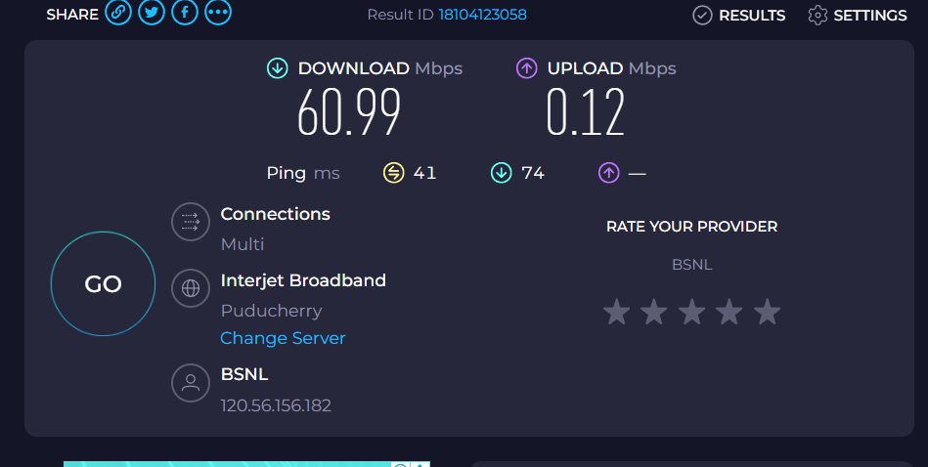

VPN CONNECTED:

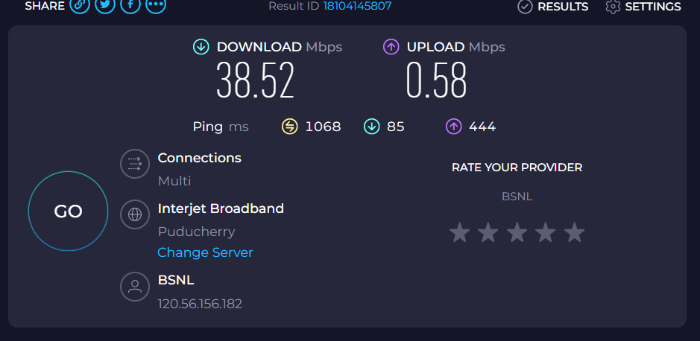

| **Status** | **Download Speed (Mbps)** | **Upload Speed (Mbps)** | **Ping (ms)** | **IP Address** | **Notes** |
| --- | --- | --- | --- | --- | --- |
| **VPN Connected** | 38.52 | 0.58 | 1068 | 120.56.156.182 | Much higher ping, reduced download speed compared to no VPN. |
| **VPN Disconnected** | 60.99 | 0.12 | 41 | 120.56.156.182 | Download speed improved, ping much lower, upload  dropped significantly. |

**\*\*\* Summary on VPN benefits and limitations**

**Benefits:**

* Hides your IP address, protecting identity online.
* Encrypts internet traffic, preventing ISP or hackers from spying.
* Allows bypassing geo-restrictions (e.g., streaming services).
* Secures public Wi-Fi connections from snooping.

**Limitations:**

* Can slow down internet speed due to encryption and rerouting.
* Some websites block VPN IP ranges.
* Free VPNs may have data limits, slower speeds, or privacy risks.
* Not a full anonymity tool—your activity can still be tracked by other means (cookies, accounts).

**\*\*\*\* Research VPN encryption and privacy features:**

* **Encryption type** – Many VPNs use AES-256 (military-grade encryption).
* **Tunneling protocols** – Examples: OpenVPN, WireGuard, IKEv2.
* **No-logs policy** – Whether the VPN stores your browsing history.
* **Kill switch** – Disconnects internet if VPN drops to prevent data leaks.
* **DNS leak protection** – Stops your ISP from seeing your DNS requests.